***Statue of old grandparents looking at albums***

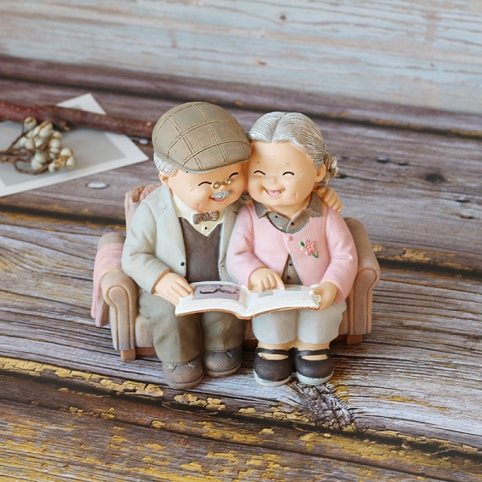

*The statue of old people watching and watching albums is made of synthetic resin. Dimensions 12cm long, 8cm wide, 11.5cm high. This is a meaningful souvenir for grandparents, as a wedding gift or for a girlfriend.*